**DAILY ONLINE ACTIVITIES SUMMARY**

|  |  |  |  |  |  |  |  |  |
| --- | --- | --- | --- | --- | --- | --- | --- | --- |
| **Date:** | **20/05/2020** | | | | | **Name:** | **Netra suresh gudagamnala** | |
| **Sem & Sec** | **VI ‘A’** | | | | | **USN:** | **4al17cs055** | |
| **Online Test Summary** | | | | | | | | |
| **Subject** | | **SSCD** | | | | | | |
| **Max. Marks** | | **30** | | **Score** | | | **22** | |
| **Certification Course Summary** | | | | | | | | |
| **Course** | **Ethical hacking in python** | | | | | | | |
| **Certificate Provider** | | | **udemy** | | **Duration** | | | **1 month** |
| **Coding Challenges** | | | | | | | | |
| **Problem Statement:** <https://github.com/NETRASG/ALVAS_ONLINE_COADING/blob/master/README.md> | | | | | | | | |
| **Status: done** | | | | | | | | |
| **Uploaded the report in Github** | | | | | **yes** | | | |
| **If yes Repository name** | | | | | <https://github.com/NETRASG/ALVAS_ONLINE_COADING> | | | |
| **Uploaded the report in slack** | | | | | **yes** | | | |

Online Test Details: (Attach the snapshot and briefly write the report for the same)

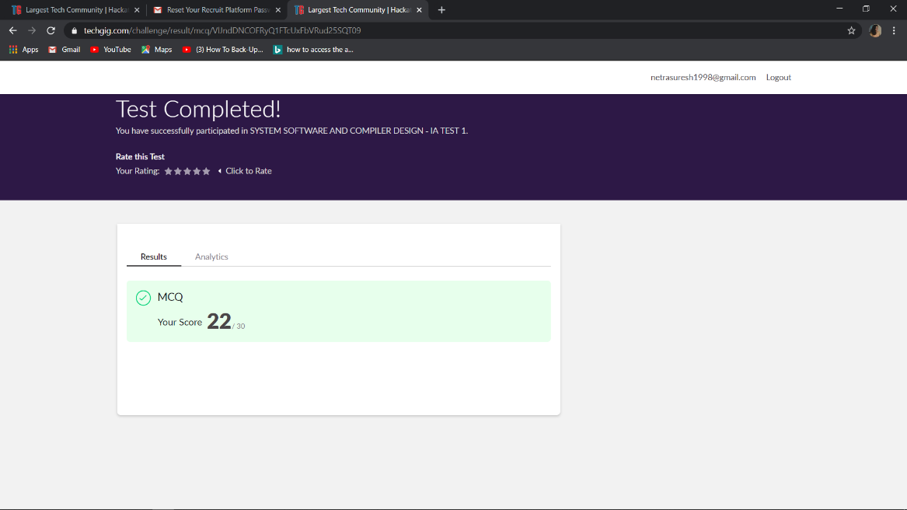

Certification Course Details: (Attach the snapshot and briefly write the report for the same)

Learning about very basic mac address changer handling command line arguments and brief description about python inbuilt functions and modules